# Testing the Event Cinema Booking system

For validating the program, a few inputs are used to check whether it responds as it is meant to or not.

For such an activity, **3** different test cases are used to verify the functionality of the system.

Test 1: find movie / find day

## User chooses listing by movie (figure 2) or by day (figure 4):

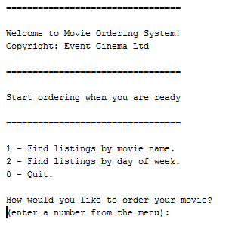

Figure Welcome screen

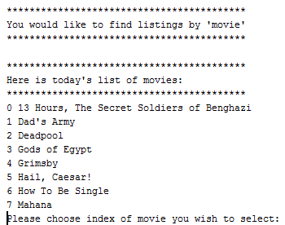

Figure : listing by movie

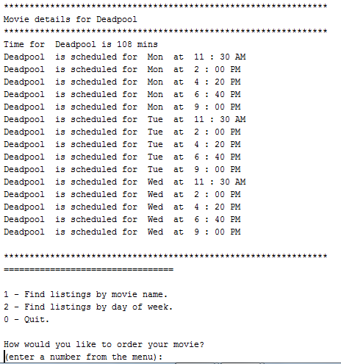

Figure : selecting '2' for Deadpool

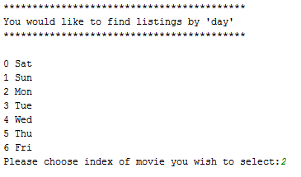

Figure : selecting listing by Day

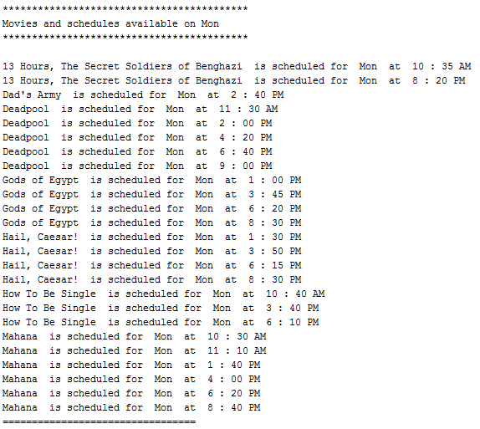

Figure : selecting "2" for Monday listings

## Entering an invalid value

To ensure that the system only accepts valid inputs, it will be tested by entering some erroneous values.

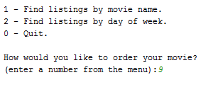

Figure : entering a number out of range

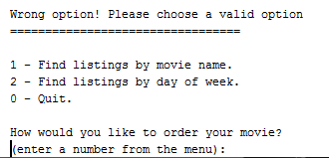

Figure : Output screen

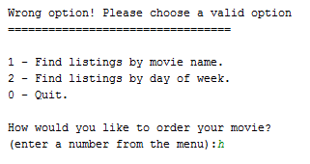

Figure : entering a letter instead of a number

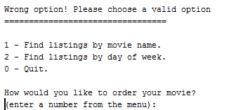

Figure : Output result

As results show, the system alerts the user that an erroneous value was inputted, and ensures that the user is given another chance at inputting a valid value.

## Entering movie details

At the end of the program, the user can enter the name, day and time of the movie he wishes to go to. The system should print a ticket on the screen for the user.

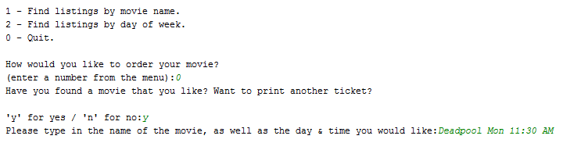

Figure : entering movie details for ticket printing

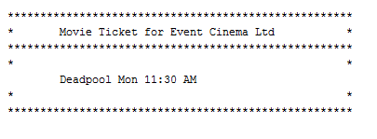

Figure : on-screen movie ticket

After printing the ticket on-screen, the user is given a chance to print another ticket. The system works as defined by the client.